**SANTA CLAUSE IS COMING TO SUGARLOAF !!**

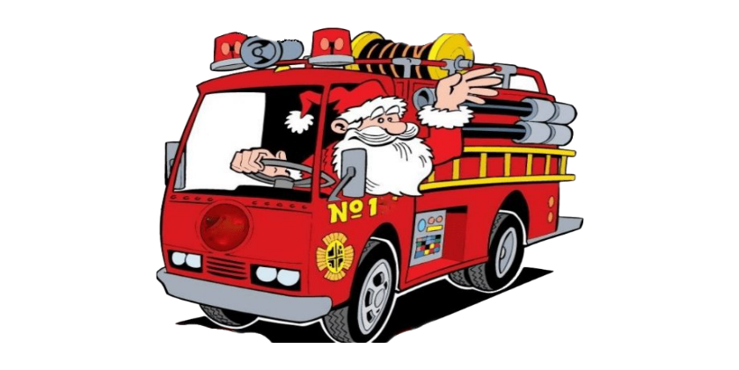

**With a little help from the Sugarloaf Fire Company!**

**A FREE EVENT FOR THE GOOD LITTLE GIRLS AND BOYS!**

**SATURDAY DECEMBER 7TH, 2024**

**Municipal Meeting Room**

**858 Main Street, Sugarloaf PA.**

**DROP IN ANYTIME BETWEEN**

**11:00 AM – 2:00 PM**

**Come tell Santa what you would like for Christmas and take your own free photo with him.**

**Gingerbread and Sugar Cookies to decorate and take home.**

**Make a Christmas Card for members of your family.**

**Hot Chocolate – Pizza –other free refreshments while they last!**

**Christmas Carols, Performance by All That Dancin’ and More! Stop in for some Township Joy!**

**Merry Christmas from the Sugarloaf Township Administration and Staff**

